# How to Completely Power Down Your iPad

When you push the power button briefly on an iPad so that its screen turns off, believe it or not, it is not completely turned off. It will continue to burn its charge at a faster rate than it would when turned off completely. Turning your iPad completely off will save battery for when you need it. If it won't turn off, you can hard reset it or restore it to fix the freeze.

**Method 1**

**Powering Down Your iPad**

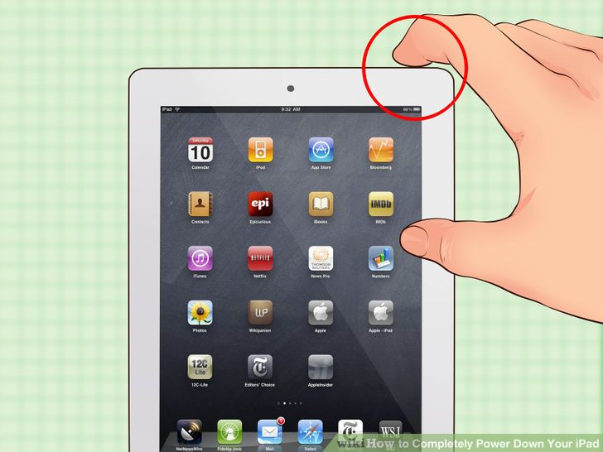

**Press and hold the Sleep/Power button.** You'll find this button along the top-right edge of the iPad.

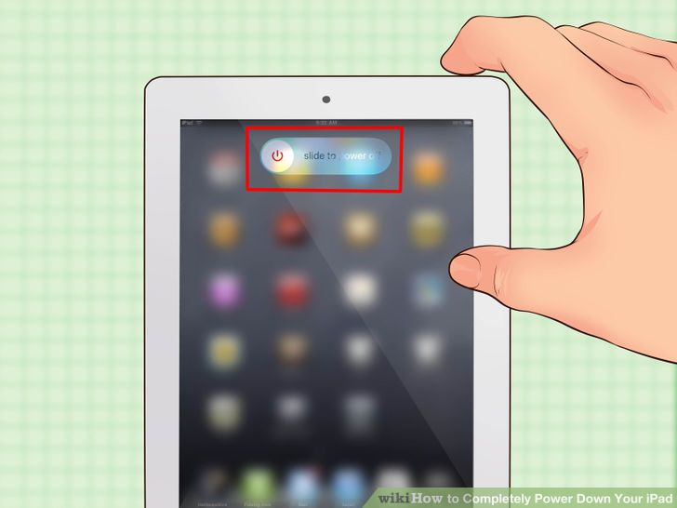

**Continue holding the button until the Power slider appears.** This slider appears on the screen at the top with the words "slide to power off," and sliding it with your finger will turn the iPad off. It may take a few moments for this to appear.

* + If your iPad is frozen and nothing happens when you press and hold the Power button, see the next section.

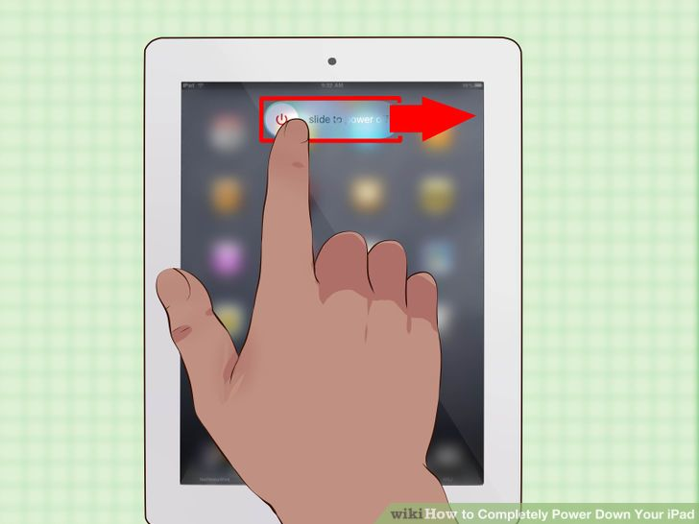

**Slide the Power slider to turn off the iPad.** This will power down the iPad completely.

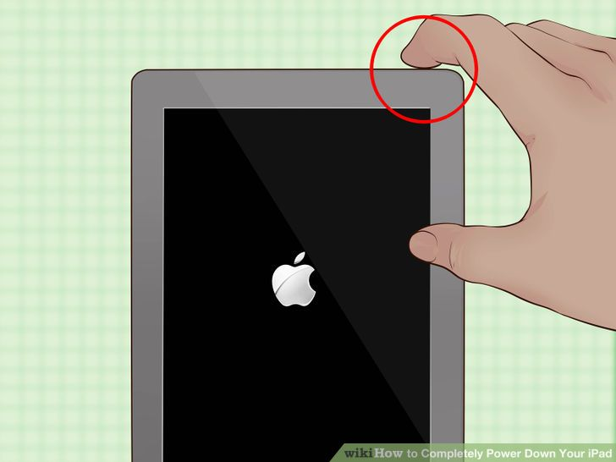

**Turn the iPad back on by pressing and holding the Sleep/Power button.** You'll need to hold the button for a few moments until the iPad screen turns on.

**Method 2**

**Hard Resetting a Frozen iPad**

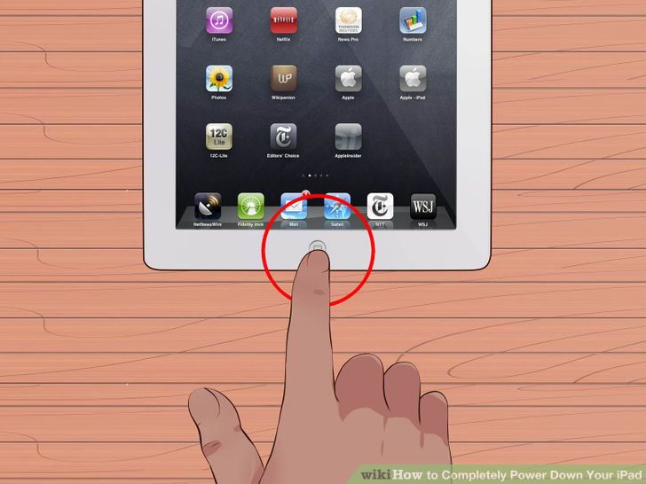

**Press and hold the Home button.** If you have a frozen iPad that won't turn off, performing a hard reset may fix the problem. Start by holding the Home button.

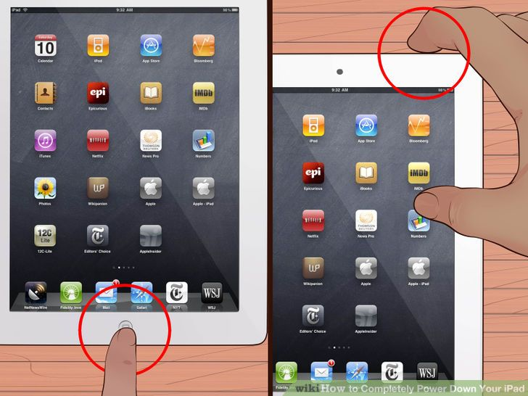

**Press and hold the Sleep/Power button while holding the Home button.** Don't let go of either button.

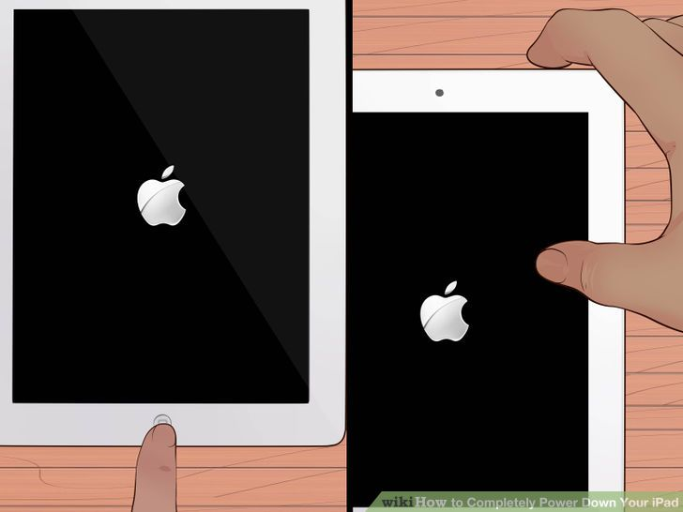

**Hold both buttons until the Apple logo appears.** This may take 20 seconds or so.

* + If you can't get your iPad to reset, even after holding the Home and Sleep/Power button for up to a minute, see the next section.

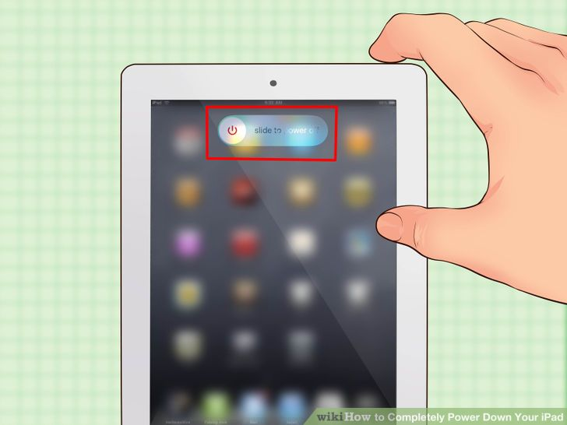

**Power off your iPad once it finishes rebooting.** Once the reboot is complete, which may take a while, your iPad will load your Home screen. You can then power it down using the method in the previous section.